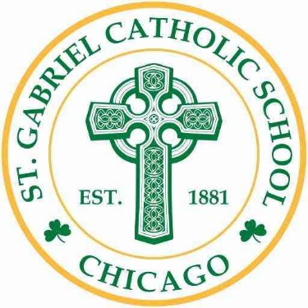 | Saint Gabriel  Catholic School

Friday, May 19, 2023

Pledge Sheet

Student Name: Grade:

 | Donor’s Name | Address | Amount Donated
1 |  |  | $
2 |  |  | $
3 |  |  | $
4 |  |  | $
5 |  |  | $
6 |  |  | $
7 |  |  | $
8 |  |  | $
9 |  |  | $
10 |  |  | $
 |  | Total

Our pledge goal for this year’s Walk-a-Thon is $25 per student. Each dollar raised is an investment in a child’s Catholic education at Saint Gabriel Catholic School. We sincerely thank you for your support.
We will be raffling off One Apple iPad to the lucky winner!

Amount Raised | Individual Incentives
$25 | Shamrock t-shirt
$50 | Shamrock t-shirt & 1 Ticket for a Raffle Drawing
$75 | Shamrock t-shirt & 3 Tickets for a Raffle Drawing
$100 | Shamrock t-shirt & 5 Tickets for a Raffle Drawing
$150 | Shamrock t-shirt & 10 Tickets for a Raffle Drawing
$200 | Shamrock t-shirt & 15 Tickets for a Raffle Drawing
$250 | Shamrock t-shirt & 20 Tickets for a Raffle Drawing

